**Project Plan: (GawuloFusion)**

**Overview**

GauloFusion is a digital solution built to modernize and streamline the food ordering experience for township-based local restaurants. By introducing a simple web-based ordering system, we aim to reduce long queues, offer convenient cashless payments, and provide real-time customer support through a chatbot.

**The Problem**

Local food businesses in townships, especially those selling African cuisine and fast food they often face:

* Long customer lines, leading to frustration and poor service delivery.
* Limited cashless payment options, despite the rise of digital banking and mobile wallets.
* Lack of visibility, since many restaurants operate without a strong online presence.
* Poor communication channels, leaving customers unsure about order progress or restaurant information.

**The Solution: GauloFusion**

GauloFusion is a user-friendly website platform built for both restaurant owners and customers:

Key Features:

1. Digital Ordering System
   * Customers can browse menus, order meals, and skip long lines by ordering in advance.
2. Card-Only Payments
   * The system is optimized for card and mobile wallet payments, minimizing cash handling and promoting safer transactions.
3. Chatbot Integration
   * A 24/7 AI chatbot will handle FAQs, offer help center services, and provide order tracking to keep customers informed.
4. Restaurant Portal
   * Owners can upload menus, set business hours, and manage incoming orders from a clean dashboard.
5. Event Listing Hub
   * A community board for local events (markets, festivals, etc.) that can increase foot traffic and support small businesses.

**Updated Milestones and Deliverables**

Phase 1: Discovery & Planning

* User Personas
* Prioritized Feature List (including card-only payments & chatbot support)
* Technical Requirements Document
* Finalized Project Timeline

Phase 2: Design & Prototyping

* UX/UI Wireframes and Mockups
* Clickable Prototype for user testing
* UX Report with chatbot flow and payment screens

Phase 3: Restaurant Portal Development

* Profile & Menu Management
* Order Handling Dashboard
* Basic Insights Analytics
* Internal Testing Report

Phase 4: Customer Platform & Event Hub Development

* Restaurant & Menu Browsing
* Order Placement with Card Payment Integration
* Real-Time Order Tracking System
* Chatbot with Help Center Features
* Event Listings Module
* Internal Testing Report

Phase 5: Testing, Deployment & Training

* Quality Assurance & Security Reports
* Deployment to Production Environment
* User Manuals (for both business owners and customers)
* Onboarding Workshops for Restaurant Owners
* Launch of MVP with full order and chatbot functionality

Phase 6: Post-Launch Support

* User Feedback System
* Scheduled Updates and Bug Fixes
* Performance Monitoring
* Feature Roadmap (e.g., delivery support, loyalty rewards, etc.)

**Prototype**  
Link to prototype: <https://www.figma.com/design/qbICBhgV9lTzi5AnsFRjGt/GaoloFusion-WebApp?node-id=0-1&t=evhLIitrDJdk0jrX-1>

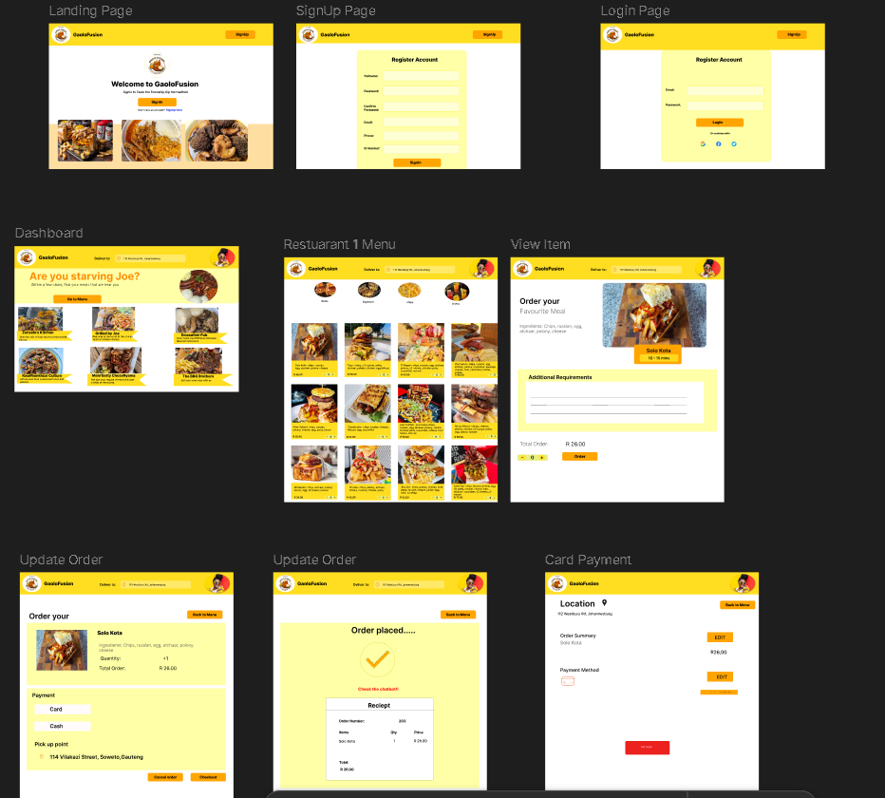  
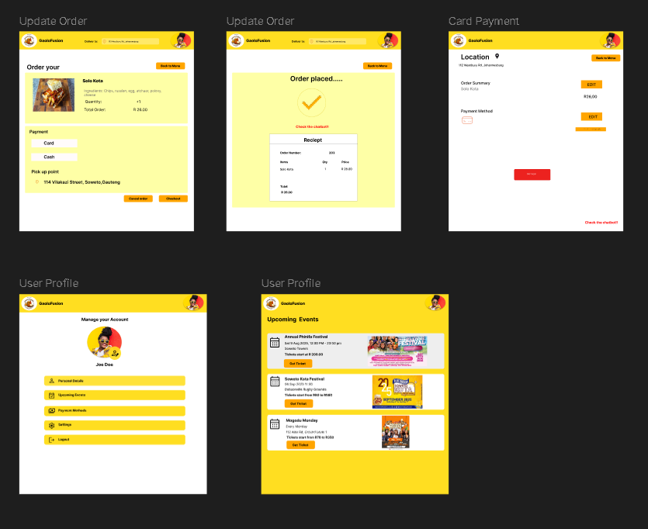

**Project Workbreakdown Structure**

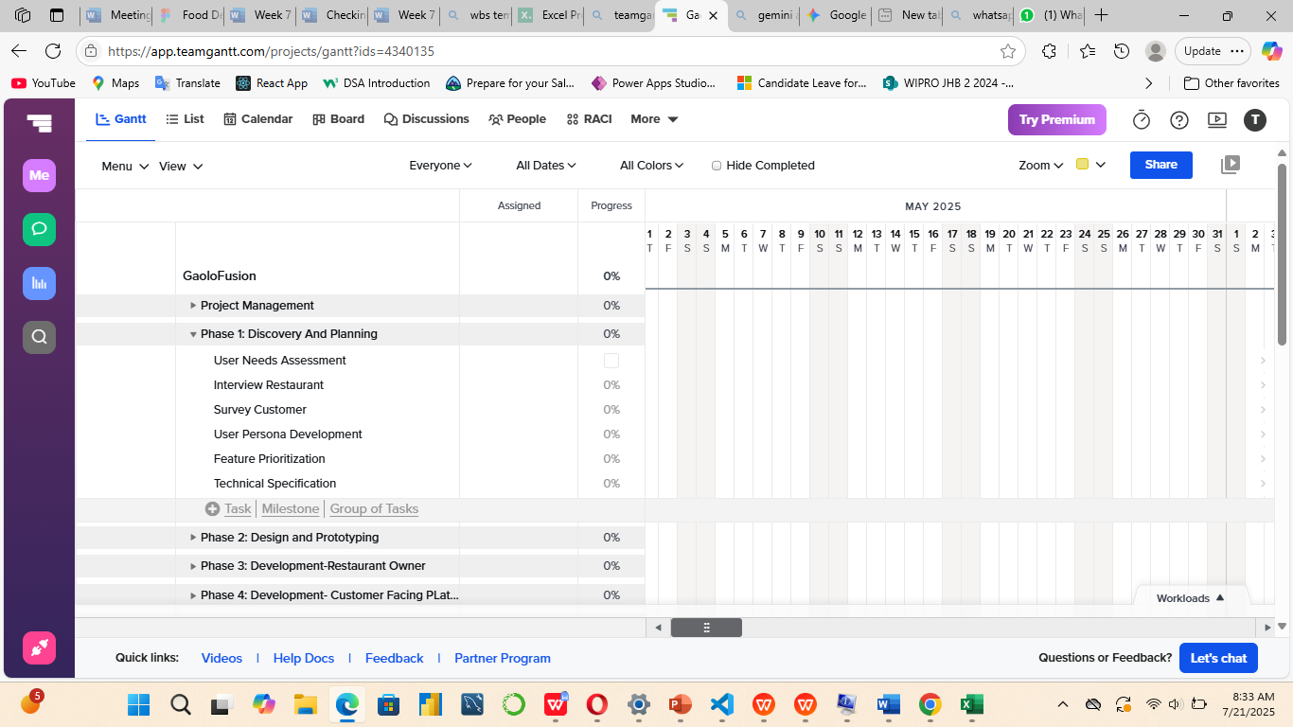

**Use Case Diagram  
  
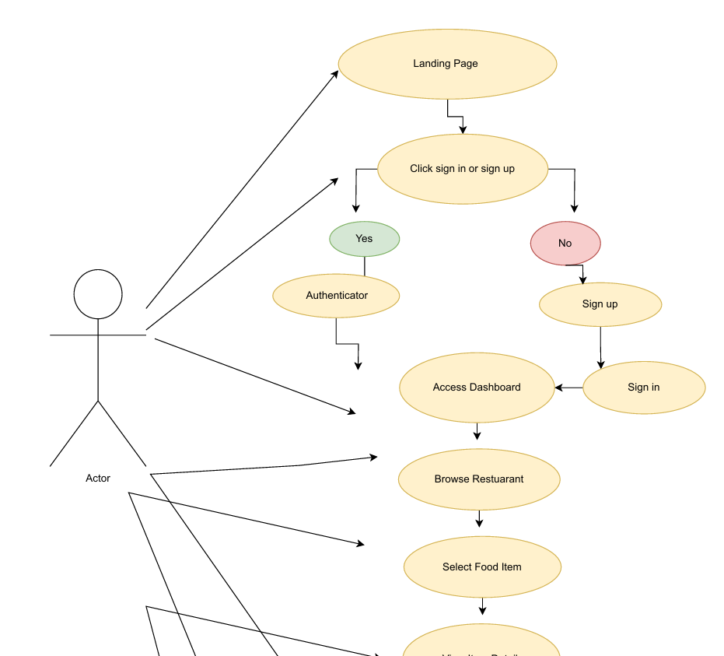**

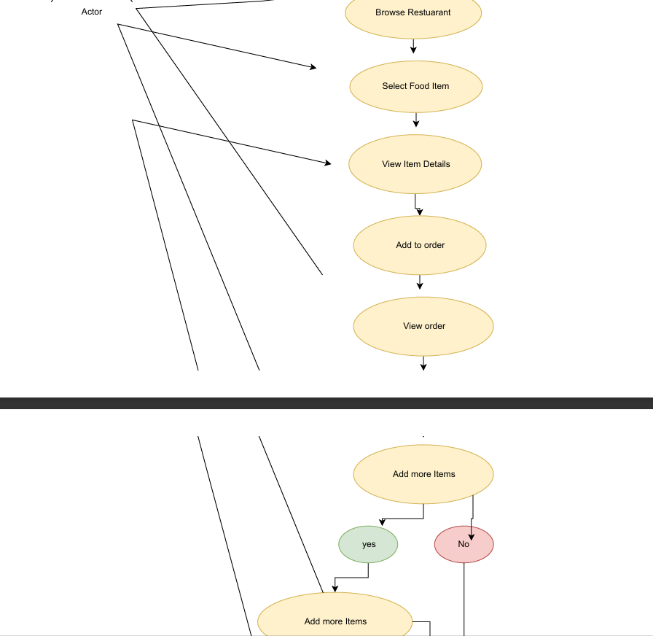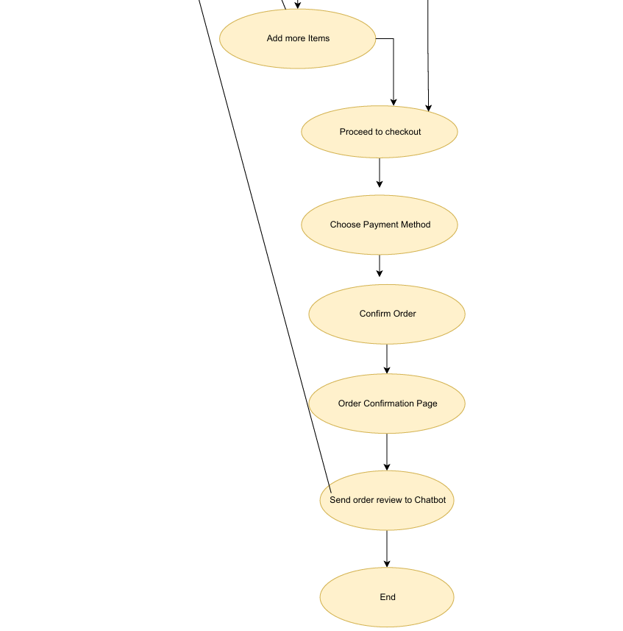

**References**

1. Firebase Documentation. (n.d.). Firebase Documentation. Google. Retrieved July 23, 2025, from https://firebase.google.com/docs
2. Figma. (n.d.). Figma: Collaborative interface design tool. Retrieved July 23, 2025, from https://www.figma.com
3. Google Developers. (n.d.). Using Firebase Authentication in web apps. Retrieved July 23, 2025, from https://firebase.google.com/docs/auth/web/start
4. Google Developers. (n.d.). Cloud Firestore: Documentation. Retrieved July 23, 2025, from https://firebase.google.com/docs/firestore
5. Icons8. (n.d.). Free Icons - Icons8. Retrieved July 23, 2025, from https://icons8.com/icons
6. MDN Web Docs. (n.d.). HTML, CSS, and JavaScript reference. Mozilla. Retrieved July 23, 2025, from https://developer.mozilla.org
7. Font Awesome. (n.d.). Font Awesome Icons. Retrieved July 23, 2025, from https://fontawesome.com
8. Claude.ai. (n.d.). Claude AI documentation. Anthropic. Retrieved July 23, 2025, from <https://www.anthropic.com>
9. Figma: Used for designing GaoloFusion’s user interface, user flows, and responsive layout prototypes.

<https://www.figma.com/design/qbICBhgV9lTzi5AnsFRjGt/GaoloFusion-WebApp?node-id=0-1&t=evhLIitrDJdk0jrX-1>